Nguyễn Nhật Trường 2111903

LAB 2: CME – SCCP – SIP

Kiểm tra kết nối giữa CME và PC ảo

Phần 1: SCCP

* Cấu hình dịch vụ



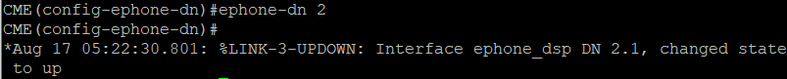

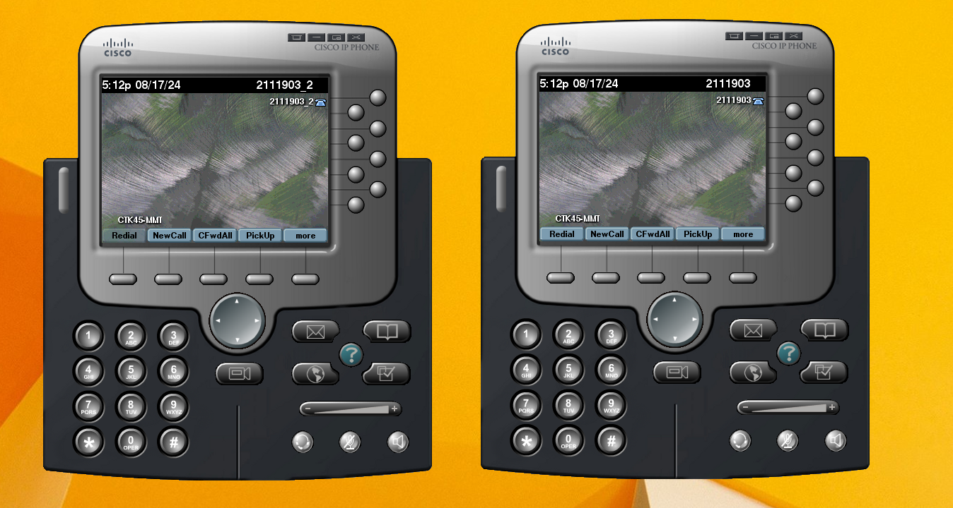

* Tiến hành gọi

* Thêm điện thoại 3 và 4

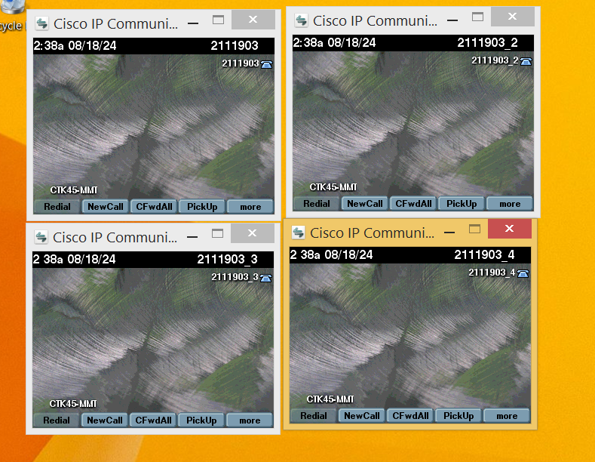

Phần 2: SIP

* Cấu hình dịch vụ

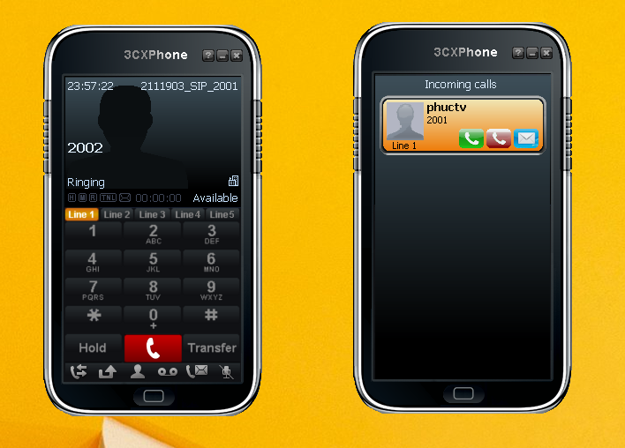

Phần 3: Giả định trường hợp



